# Using Georeferenced Data to Understand the Influence of Weather Conditions on COVID-19

One-sentence summary: People in countries of all climates are at risk of being infected by COVID-19; cold weather can exacerbate their risk.

Francois Cohen[1], Anant Jani[2], Sihan Li[3], Yangsiyu Lui and Moritz Schwarzi,[4]

This version: April 9th 2020; first version: April 1st 2020; data update: April 8th, 2020.

125 words

**Abstract:** COVID-19 could be sensitive to weather conditions. We match georeferenced confirmed cases data with daily reanalysis weather data to test this hypothesis. The granularity of our data allows us to deal with the issues of omitted variable bias and measurement error that have undermined previous attempts. We produce the first study that accounts for national day-to-day changes in government response, population behaviour, and changes in coronavirus testing. We find that cooler temperatures by 1°C over a 22-day period leads to an increase in the daily growth rate of confirmed cases by 1.0 percentage point [0.7 – 1.3]. The virus is able to spread quickly in all countries, and even more so under cold weather. Stringent public health interventions are required under all types of climates.

Coronavirus Disease (COVID-19), caused by the SARS-CoV-2 virus, is a novel disease first identified in Wuhan, China in December 2019. As of April 9th, 2020, it has spread all over the world with 1,476,819 cases confirmed, and 87,816 deaths.[5] At the early stages of the pandemic, several health experts and world leaders commented that the onset of summer weather might slow down the spread of the virus[6],[7],[8],[9] based on evidence for other coronaviruses, especially MERS and SARS-CoV-1 [10],[11],[12],[13],[14],[15],[16]. However, a multitude of cases of COVID-19 have been reported in hot and humid regions since, suggesting that this new virus may in fact be more resistant to heat than other coronaviruses.[ref]

This study aims to understand if weather is an additional risk factor facilitating the spread of the disease. This is a difficult question to answer because so many variables beyond the weather influence the spread of the virus. For example, governments and the public have taken swift action to respond to the pandemic, and these actions may happen to correlate with changes in seasons and in the weather. Not accounting for these policies would produce biases in the statistical estimations. Such biases are likely to explain why the correlation analyses performed so far on COVID-19 and the weather (with data from China[17],[18],[19],[20],[21] or other countries[22],[23],[24],[25],[26]) have produced divergent estimates. A recent unpublished study by Carleton and Meng (2020)[27] is also unable to overcome these challenges, as the authors aggregate weather variables across countries, representing large geographical units and hence creating measurement error, while using national COVID-19 case counts, not allowing them to avoid omitted variable bias by e.g. controlling for changes in national policy.

The main contribution of this paper is to overcome the methodological issues of previous attempts, and therefore produce an estimate of the impact of weather conditions that is substantially less subject to potentially misleading estimation biases. To do so, we use precise georeferenced data, and introduce stringent controls that have not been used so far in statistical estimation of the impact of the weather on COVID-19. In particular, we control for country-level day-to-day changes in the behaviour of populations, government response and the availability of COVID-19 tests. We furthermore control for local climatic conditions with area by week fixed effects, to make sure that our estimates are not caused by spurious correlations between COVID-19 and local seasonal trends.

We find that a 1°C reduction in temperature over 22 days leads to an increase in the daily growth rate of confirmed COVID-19 cases by 1 percentage point [0.7 – 1.3]. Given this estimate, we fail to reject the hypothesis that the virus is insensitive to weather, and therefore postulate that the end of the summer season in both Hemispheres could alter the susceptibility of the population to new infections and hence many ountries could witness significant increases in confirmed cases. These findings cannot be easily interpreted the other way around – heat as an attenuating factor – because we already know that the virus is capable of spreading quickly in warm regions.

This information could be essential in the fight against the pandemic. Health experts should consider the influence of weather conditions in their COVID-19 related projections. We caution in the strongest possible terms against any de-prioritisation of strong public health responses in epidemics in warming climates in light of these results. People have no reason to feel protected against the virus during hot days. What happens is that they may be even more vulnerable during cold days.

## Using georeferenced data

We link the real-time geo-referenced epidemiological data from Xu et al. (2020) (see **Figure 1**) to meteorological data from the 5th generation of European Centre for Medium-Range Weather Forecasts atmospheric reanalyses of the global climate (ECMWF-ERA5).[28]

In their own words, Xu et al. (2020) “have built a centralised repository of individual-level information on patients with laboratory-confirmed COVID-19”. It constitutes a rigorous, multinational effort to improve statistics on COVID-19. The data includes data from 6th January onwards and is updated on a regular basis. It provides information on the longitude and the latitude with the highest resolution available of confirmed COVID-19 cases globally. We use this information to track the progression of severe, confirmed COVID-19 cases in 2775 areas spanning 99 countries.[29] The main advantage of the data from Xu et al. (2020) is its granularity: it allows us to produce analyses at sub-national level rather than at a country level, allowing us to introduce the strict controls discussed below in our statistical analysis. The main drawback of using this data is that it does not cover all COVID-19 cases but only a sample for the covered areas and the considerable data-update lag of several days. The March 29th version has much fewer cases after March 23rd (see below). The data includes 112,970 individual cases compared to a total 338,298 of confirmed COVID-19[30] until March 23rd.

Some of these sampling issues are dealt with in our statistical analysis because most differences in data collection and reporting across geographies and time will be controlled for. However, this does not change the fact that we can only look at confirmed COVID-19 cases. The number of confirmed cases in each region depend, among other factors, on the number of tests conducted and as testing policy varies across countries and administrative areas, confirmed cases are highly likely to always underestimate the progression of the disease to a certain degree, especially the number of cases with mild symptoms. The data is therefore more capable of detecting severe cases than it is at detecting the actual transmission of the disease. From a policy perspective, confirmed COVID-19 cases are still a very important indicator. They correspond to those cases of severe illness that may lead to intensive hospitalisation or death. Please also note that we cannot use confirmed COVID-19 deaths, alongside confirmed cases, because we are unaware of an equivalent dataset for confirmed COVID-19 deaths with appropriate georeferences.

The meteorological dataset used in this study (ECMWF-ERA5) is a climate reanalysis dataset. It provides consistent weather data with high spatial (~0.25 degrees) and temporal (hourly) resolutions, while of course being unable to control for the systematic bias inherent to all climate models. We use daily averages and consider total precipitation, average, maximum, and minimum temperature as well as relative humidity (calculated using temperature and dewpoint temperature). We provide summary statistics for the meteorological data in the **supplementary material 1**.

**Figure 1: Confirmed cases and infected areas**

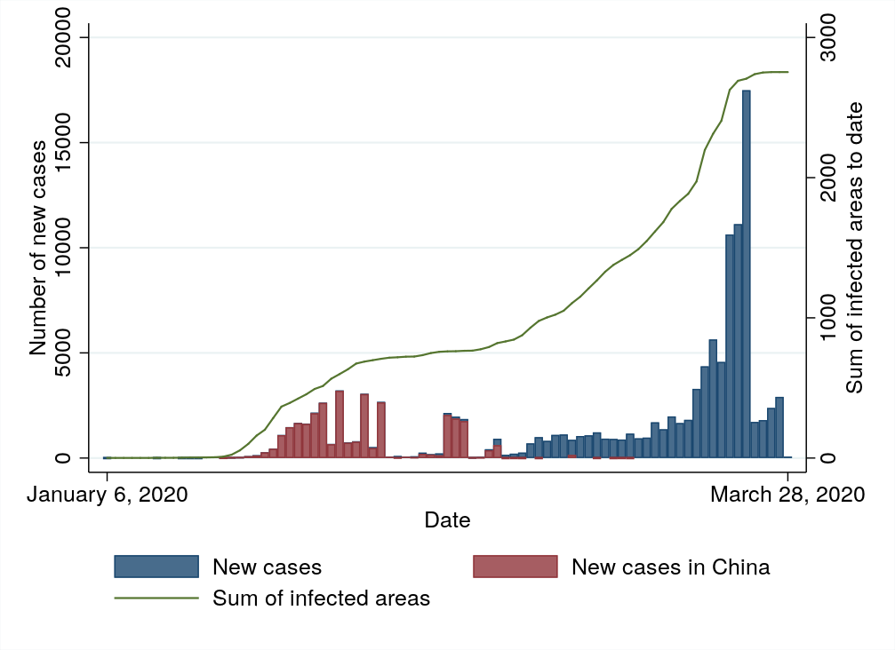

Sources: own calculations based on Xu et al. (2020)

## Controlling for changes in policy, behaviour and testing practices

The statistical model is a distributed lag model applied on daily panel data. It is presented in detail in the **supplementary material 2**.

In short, the model uses daily counts of confirmed COVID-19 cases across small geographic areas (either precise locations, regions, or cities). Since infections can only be proportional to the number of people already infected in an area, the model looks at changes in confirmed cases in each area at time t based on the number of confirmed cases on the day before $(t-1)$. We use the following transformation: $ln⁡(C_{i,t})-ln⁡(C_{i,t-1})$, where $ln⁡(C_{i,t})$ is the natural logarithm of the total number of confirmed cases of COVID-19 observed in area $i$ on day $t$. We only include daily observations of areas with at least one case confirmed.

The model also takes into account that the incubation period of COVID-19 can take up to two weeks. Our baseline model focuses on average temperature. We estimate the impacts of the average temperatures of the days before time t. The average temperature impact is estimated separately for every single day leading up to the confirmation of the COVID-19 diagnosis as well as on the day itself. The overall impact of weather conditions is then aggregated over a 22-day window period, which aggregates both the coefficient estimates as well as the associated standard error estimates. We chose 22 days (i.e. the day of the case-confirmation plus 3 weeks) because we know that the incubation period is generally estimated to last up to two weeks, and to allow for an extra week before the case is confirmed. We consider a number of other lag-specifications to test the sensitivity of this choice, but we generally find the estimated effects to be very stable after 12 days (see **supplementary material 2**). The effects estimated by the model can be interpreted as the impact that a 22-day long prior exposure to different weather conditions has on new COVID-19 cases at time t.

We designed the model in a way to separate the impact of weather conditions from other confounding factors such as sudden changes in policy, behaviour, and healthcare practices. To do so, we introduce a number of fixed effects to the model. Introducing “country-by-day” fixed effects has the effect that the statistical model only compares areas to each other, if they are located in the same country, and for cases that have been recorded on the same day. This controls for the fixed differences between countries, as well as for day-to-day changes in country-level policy, virus prevalence and COVID-19 testing. We furthermore control for the risk that changes in local climatic conditions from one week to the other could be spuriously correlated with the spread of COVID-19 by including “area-by-week” fixed effects. These fixed effects also control for the fact that some areas could be reporting more cases (e.g. due to wider testing or advanced medical care system) in a given week.

The central assumption of our model is that the remaining variation in the weather, after including the fixed effects, is pseudo-random. For a given area within a week, and accounting for general trends at national level, we assume that the distribution of hotter and colder days is random (Tuesday in Paris is cold vs. Friday in Paris is cold). The effect of the weather is then identified by comparing contemporaneous differences in the number of reported cases in one area compared to another area located in the same country. The model furthermore considers that expected weather conditions evolve every week at the level of each area, and that some areas may also be more likely report more cases in a given week compared to the rest of the country.

## Results

**Figure 2** provides a graphical representation of the estimation results. We look separately at the impact of average temperature on COVID-19 cases outside China (upper left panel) and exclusively in China (upper right panel). We do this because the pandemic started much earlier in China than elsewhere. The graphs provide separate estimates of the impacts of temperature at different ranges (e.g. “below 0°C” compared to “10-20°C”). Because China did not record very hot days in our sample, the high temperature category (>30°C) is not reported in the case of China.[31] In the lower panels of Figure 2, we furthermore provide results for minimum temperatures (blue) and maximum temperatures (red). These lower panels provide estimates for all observations together (in China and outside China).

**Figure 2: Impact of temperatures on confirmed COVID-19 cases**

|  |  |
| --- | --- |
| **Outside China** | **In China** |

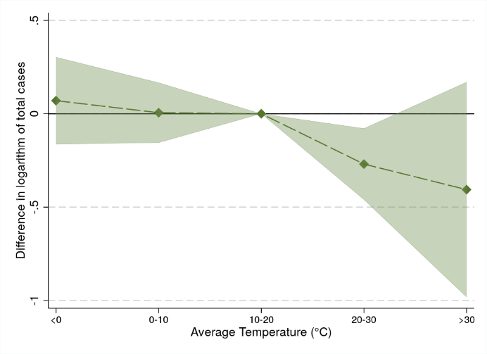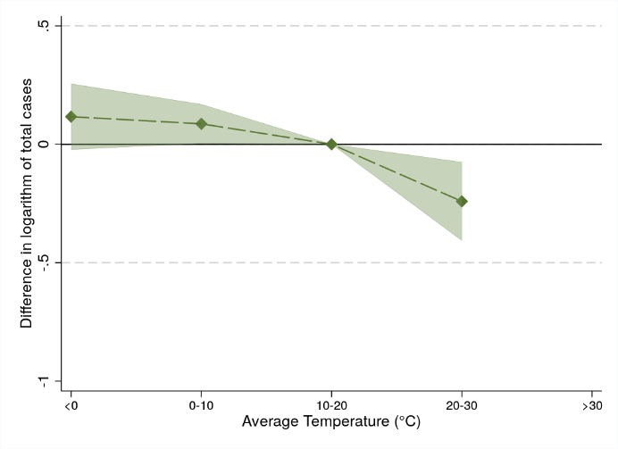

|  |  |
| --- | --- |
| **Minimum Temperature** | **Maximum Temperature** |

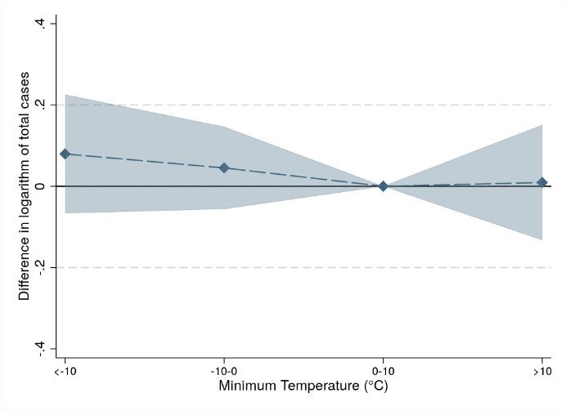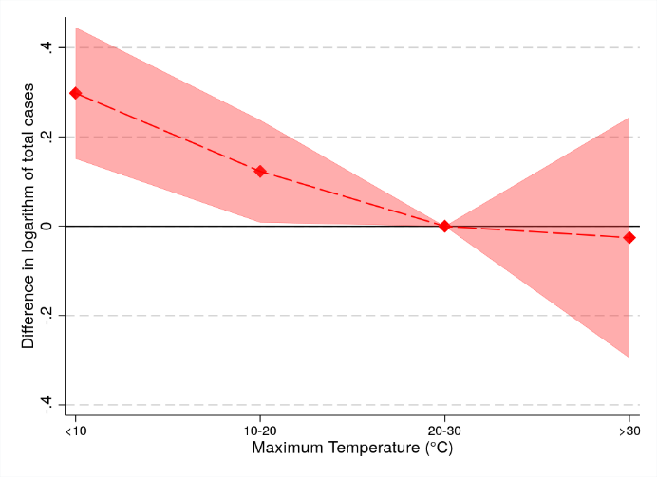

Notes: Shaded areas represent 95% confidence intervals. These graphs have been obtained using 10°C-wide temperature bins (and their 21 lags) to capture non-linearities in the response of COVID-19 to the weather. These bins take the value of 1 (and 0 otherwise) if the temperature on the specified day falls within a specific range, e.g. either “<0°C”, “0-10°C”, “10-20°C”, “20-30°C” or “>30°C” in the case of average temperatures. The regressions used to obtain the graphs for average temperature (in green) controls for area-by-week fixed effects and country-by-day fixed effects. The other two graphs (maximum temperatures in red, and minimum temperatures in blue) display results from one regression using the same controls. This regression includes two sets of temperature parameters (for minimum and maximum temperatures). Standard errors are clustered at country level, except for the estimates for China, where standard errors are clustered at the level of areas.

We find a difference in the surge of new COVID-19 cases between colder and warmer days. Effects seem to be driven by maximum temperatures. In **supplementary material 3**, we linearize the impacts displayed in **Figure 2** to increase precision and calculate marginal effects. Globally, we find that a 22-day exposure to cooler temperatures by 1°C leads to an increase in the daily growth rate of total cases by 1.0 percentage point [0.7 – 1.3]. Effects are similar for Chinese confirmed cases , at 0.9 percentage points [0.01 – 1.9], and all confirmed cases outside of China at 0.8 percentage points [0.4 – 1.1]. Given that in our sample, the average daily growth rate of new cases so far is 8%, the influence of cold weather as a risk factor is sizeable (an increase of the sample average daily growth rate by 12.5% 1°C cooler temperatures).

We conducted several robustness checks in the **supplementary material 3**. [HUMIDITY AND PRECIPITATIONS]. We check how important the fixed effects are to avoid mis-identifying the impact of the weather on COVID-19. Taking out the fixed effects lead to attenuated results, possibly because the virus is spreading while temperatures are increasing. We check whether the length of the window period has an impact on the results. The effects increase with the number of lags, and then remain stable after 21 lags. We also look at the impact of the weather on the early spread of the disease in new areas, as well as before and after within-country movement restrictions were introduced. We find that, in the early stages, before strong policy intervention, the weather is likely to have played a similar role in how fast the disease spread. As we get more data about the pandemic, it should be possible to refine these estimates.

## Using these estimates in projections

Our findings could be used to calibrate projections of the pandemic based on local weather conditions. Mathematical models of epidemic dynamics are needed to use this result for forecasting, which is beyond the scope of this work.

Please note several caveats regarding our estimates. Our estimates do not have the predictive capacity required to make robust forecasts about the upcoming winter and summer seasons. This is because econometric models can only predict changes at the margin. These models have no ability to predict changes in temperature beyond a few degrees. We strongly warrant against multiplying of effect (11%) by the number of degrees (e.g. a 5°C change in temperature) to make rule of thumb forecasts. This does not work because the marginal, degree increases cannot be extrapolated beyond a few degrees, and many factors could come into play, which could lead to a surge in confirmed cases even at high temperatures. Moreover, we are using data over a few months only, and have used winter data in the Northern Hemisphere and summer data in the Southern Hemisphere to understand the virus’ response. Any projection will need to make strong assumptions about the validity of these responses beyond the periods and situations observed. Nothing ensures that the relationship we estimate might not evolve. If public health measures are relaxed in the summer and people go out more during hot days, we could observe a different relationship in a few months, with more cases recorded in the summer.

Having said so, we illustrate below the effect that our estimates could have on projections, using a very simple susceptible-infectious-recovered (SIR) compartment model.[32] Please note that this exercise is only illustrative. The model is initialised with the parameters used in Walker et al. (2020)[33] (see methodological details in the **supplementary material 4**). Results across different scenarios suggest that some countries, especially in the Northern Hemisphere, could expect some reduction in cases from April to August, while others, especially in the Southern Hemisphere could expect a surge in cases because of weather conditions. This is illustrated across three scenarios (no mitigation, social isolation of the elderly, isolation for the whole population, as in Walker et al. 2020) in **Figure 3**, assuming a basic reproduction number $R_{0}$ of 2.4.

**Figure 3: Illustrative projection with and without taking the weather into account**

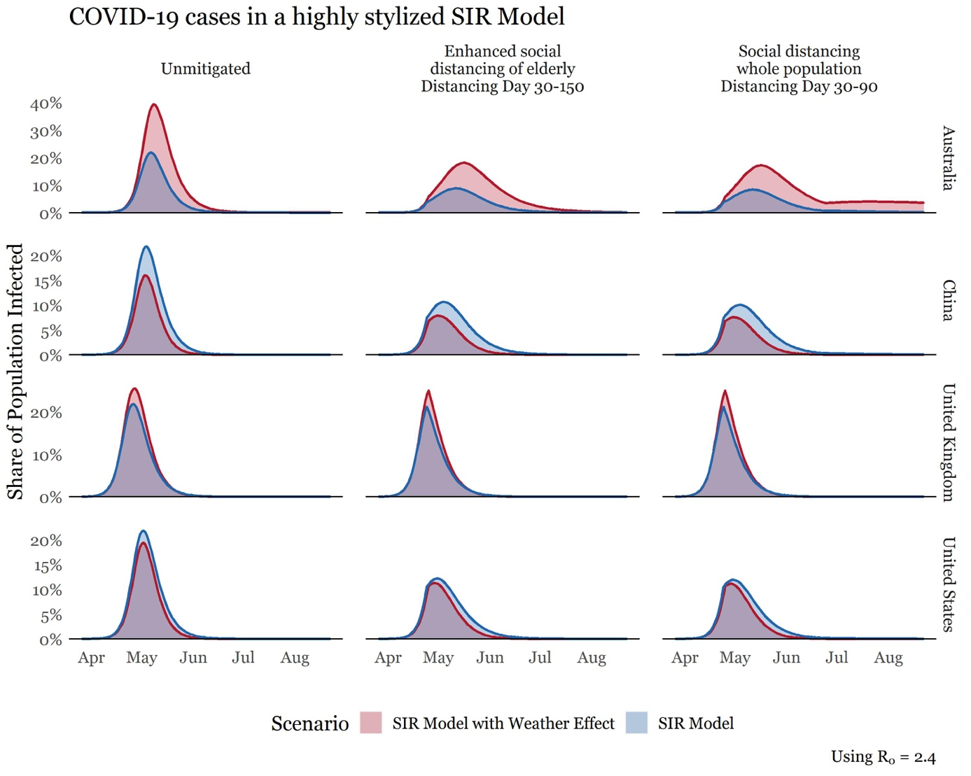

Notes: see methodological details in supplementary material 4.

## Discussion

This study concludes with some confidence that cold weather is a risk factor in the emerging of severe cases of COVID-19. [QUICKLY MENTION THE POSITIVES HERE]

However, any comparable macro-statistical analysis is unable to identify the mechanisms behind these results. This is an area where future clinical research and statistical research are required before drawing any hasty policy implication. We can cite a few mechanisms that could explain our results. For example, the COVID-19 virus itself may be sensitive to the weather, like other coronaviruses (i.e. SARS-CoV-1).[34],[35] Human immune systems may also be impaired by colder and dryer weather, and therefore people may be more likely to be infected or develop stronger symptoms during colder weather.[36] Moreover, the weather is correlated with all sorts of diseases, especially other respiratory diseases. There may be more complications from COVID-19 on cold days because of this, and therefore more confirmed cases in our data. In addition, all sorts of behavioural factors may correlate with the weather and affect population exposure to COVID-19. The results presented above encompass all these effects and possibly more.

In addition, the results for the non-linear response of COVID-19 cases to the weather do not account for acclimatization. It is possible that populations used to colder weather are less likely to contract the disease at a given temperature than populations used to hotter weather. We do not have the data to test if some versions of the COVID-19 virus are more sensitive to the weather than others. Likewise, we were unable to provide estimates by age, gender or according to medical preconditions due to lack of data. We are also disregarding the fact that some cases might have contracted the disease in a different location, which may create some measurement error in the weather variable. Finally, we do not account for air pollution, which could be confounded with temperature and have an impact on COVID-19 cases. However, we control for precipitations, a parameter known to be strongly correlated with pollution, and find no effect of precipitations on the frequency COVID-19 cases.

## Conclusion

This paper provides the first georeferenced statistical analysis of the impact of the weather on COVID-19 infections. It links detailed data on confirmed COVID-19 cases to detailed meteorological data. This allows us to separate the effect of the weather from a long list of potential confounders, especially sudden changes – from one day to the other – in government response, population awareness or even healthcare practices and COVID-19 testing.

We provide evidence to reject the hypothesis that COVID-19 is insensitive to the weather, raised by several experts. Cold is a risk factor: exposure to cooler temperatures by 1°C over a 22-day period leads to an increase in the daily growth rate of confirmed cases by 1.0 percentage point [0.7 – 1.3]. In contrast, COVID-19 seems sufficiently robust to changes in the weather to survive all seasons. Considering how fast the virus has spread, changes in weather conditions may facilitate the spread of the virus, not limit it, because the virus may flare up each time temperatures decrease. Beyond that, we warrant against any misinterpretation of our results without medical or statistical training. Nothing in this statistical analysis can be taken to justify an otherwise unsubstantiated relaxation of social-distancing or quarantining policies. Such actions, if unsupported by epidemiological evidence and projections, could endanger many lives.

Our estimates and the method provided in this paper could improve healthcare-demand projections by highlighting an additional significant factor in the challenge to combate COVID-19.

Our findings can only be interpreted cautiously. We know that warm countries like Australia and Brazil have been rapidly infected by the virus. Our findings suggest that the virus may spread even faster when these countries enter their winter season. This could put the Southern Hemisphere at increased risk during the next few months, and we could see the virus flare up again next autumn in the Northern Hemisphere. We warrant against misinterpreting our results the other way around, i.e. an increase in temperature leading to a reduction in cases. The steady increase in confirmed COVID-19 cases in hot countries clearly suggest that populations are at high risk even under warmer weather. These findings offer no justification to relax stringent public health interventions in any climate. Relaxing those and encouraging risky behaviour with respect to COVID-19 would severely endanger lives, even in hot countries, or in summer.

## Conflict of interest statement

The authors have no conflict of interest.

## Authors’ contributions

Cohen is the first author. He had the original idea, wrote most of the paper and the code to produce the econometric analysis. He also coordinated the team. Li produced the required climate data. Lu helped on literature review, on coding the econometric analysis and on producing the tables. Schwarz helped on data coding and matching and created the projections. All authors contributed to the text.

## Acknowledgements

For useful comments, we thank Doyne Farmer, David Hendry, Cameron Hepburn, Francois Lafond and Rafael Perera. For technical IT assistance, we thank David Ford. For copyediting, we thank Jack Smith.

## REFERENCES

1. Smith School of Enterprise and the Environment, University of Oxford; and Institute for New Economic Thinking at the Oxford Martin School, University of Oxford.
2. Nuffield Department of Primary Care Health Sciences, University of Oxford.
3. Environmental Change Institute, University of Oxford.
4. Climate Econometrics, Nuffield College, Oxford.
5. Figure provided by Our World in Data (<https://ourworldindata.org/coronavirus>), based on European CDC’s latest situation updates worldwide: [https://www.ecdc.europa.eu/en/geographical-distribution-COVID-19-cases](https://www.ecdc.europa.eu/en/geographical-distribution-2019-ncov-cases). Website consulted on March 28th, 2020.
6. Ravilious, K. (2020). Will spring slow spread of coronavirus in northern hemisphere? *The Guardian*, 11th March 2020.
7. Clive Cookson. (2020). Scientists hopeful warmer weather can slow spread of coronavirus. *The Financial Times*, 25th March 2020.
8. Sheikh K. & Londoño, E. (2020). Warmer Weather May Slow, but Not Halt, Coronavirus. *The New York Times*, 22nd March 2020.
9. CNBS. (2020). It’s a ‘false hope’ coronavirus will disappear in the summer like the flu, WHO says. Published 6th March, 2020: <https://www.cnbc.com/2020/03/06/its-a-false-hope-coronavirus-will-disappear-in-the-summer-like-the-flu-who-says.html> [Accessed March 31st, 2020]
10. Weiss and Navas-Martin (2005). Coronavirus pathogenesis and the emerging pathogen severe acute respiratory syndrome coronavirus. Microbiol. Mol. Biol. Rev. 69, 635–664 .11.
11. Shaman and Kohn (2009). Absolute humidity modulates influenza survival, transmission, and seasonality. Proceedings of the National Academy of Sciences 106.9: 3243-3248.
12. Mäkinen et al. "Cold temperature and low humidity are associated with increased occurrence of respiratory tract infections." Respiratory medicine 103.3 (2009): 456-462.
13. Lowen et al. (2007). Influenza virus transmission is dependent on relative humidity and temperature. PLoS Pathog. 3, 1470–1476
14. Chan, K. H. et al. The Effects of Temperature and Relative Humidity on the Viability of the SARS Coronavirus. Advances in Virology vol. 2011 1–7 (2011)
15. Schoeman et al. (2019). "Coronavirus envelope protein: current knowledge." Virology journal 16.1 69.
16. Stadler et al. (2003), SARS—beginning to understand a new virus." *Nature Reviews Microbiology* 1.3: 209-218. Advances in Virology vol. 2011 1–7 (2011).
17. Ma, Y., Zhao, Y., Liu, J., He, X., Wang, B., Fu, S., ... & Luo, B. (2020). Effects of temperature variation and humidity on the mortality of COVID-19 in Wuhan. *medRxiv*.
18. Wang, J., Tang, K., Feng, K., & Lv, W. (2020). High Temperature and High Humidity Reduce the Transmission of COVID-19. *Available at SSRN 3551767*.
19. Poirier, C., Luo, W., Majumder, M. S., Liu, D., Mandl, K., Mooring, T., & Santillana, M. (2020). The Role of Environmental Factors on Transmission Rates of the COVID-19 Outbreak: An Initial Assessment in Two Spatial Scales. *Available at SSRN 3552677*.
20. Gupta, D. (2020). Effect of Ambient Temperature on COVID-19 Infection Rate. *Available at SSRN 3558470*.
21. Oliveiros, B., Caramelo, L., Ferreira, N. C., & Caramelo, F. (2020). Role of temperature and humidity in the modulation of the doubling time of COVID-19 cases. *medRxiv*.
22. Bannister-Tyrrell, M., Meyer, A., Faverjon, C., & Cameron, A. (2020). Preliminary evidence that higher temperatures are associated with lower incidence of COVID-19, for cases reported globally up to 29th February 2020. *medRxiv*.
23. Bukhari, Q., & Jameel, Y. (2020). Will Coronavirus Pandemic Diminish by Summer? *Available at SSRN 3556998*.
24. Chen, B., Liang, H., Yuan, X., Hu, Y., Xu, M., Zhao, Y., ... & Zhu, X. (2020). Roles of meteorological conditions in COVID-19 transmission on a worldwide scale. *medRxiv*.
25. Wang, M., Jiang, A., Gong, L., Luo, L., Guo, W., Li, C., ... & Chen, Y. (2020). Temperature significant change COVID-19 Transmission in 429 cities. *medRxiv*.
26. Araujo, M. B., & Naimi, B. (2020). Spread of SARS-CoV-2 Coronavirus likely to be constrained by climate. medRxiv.
27. Carleton, T., & Meng K. (2020). *Causal empirical estimates suggest COVID-19 transmission rates are highly seasonal*. Unpublished draft available at: <http://www.kylemeng.com/> [Accessed 1st April, 2020]
28. Downloadable from Copernicus Climate Change Service: <https://cds.climate.copernicus.eu/>
29. The statistical model, however, only relies on the data for 47 countries and 2260 areas, because it needs at least two areas covered within each country in the dataset, and they have to be far enough (e.g. 25km away) to each other to record differences in the weather. Else, the model is not capable of separating the effect of temperature in these areas from the country by day fixed effects.
30. Figure provided by Our World in Data (<https://ourworldindata.org/coronavirus>), based on European CDC’s latest situation updates worldwide: [https://www.ecdc.europa.eu/en/geographical-distribution-COVID-19-cases](https://www.ecdc.europa.eu/en/geographical-distribution-2019-ncov-cases). Website consulted on March 28th, 2020.
31. Very high temperatures were only recorded in the Southern Hemisphere since our data is for January-March 2020.
32. Kermack, W. O., and A. G. McKendrick. 1927. “A Contribution to the Mathematical Theory of Epidemics.” *Proceedings of the Royal Society, Series A* 115: 700–721.
33. Walker et al. (2020). *Report 12: The Global Impact of COVID-19 and Strategies for Mitigation and Suppression*. Imperial College COVID-19 Response Team. Available at: <https://www.imperial.ac.uk/media/imperial-college/medicine/sph/ide/gida-fellowships/Imperial-College-COVID19-Global-Impact-26-03-2020v2.pdf> [Accessed March 31st, 2020]
34. Thomas Pietschmann, Will warmer weather stop the spread of the coronavirus?, available at: <https://www.dw.com/en/will-warmer-weather-stop-the-spread-of-the-coronavirus/a-52570290> [Accessed March 31st, 2020]
35. van Doremalen et al. (2020) "Aerosol and Surface Stability of SARS-CoV-2 as Compared with SARS-CoV-1." *New England Journal of Medicine*.
36. Gasparrini, Antonio, et al. "Mortality risk attributable to high and low ambient temperature: a multicountry observational study." *The Lancet* 386.9991 (2015): 369-375.